Introduction:
1) Good Day! If I could please have everybody’s attention. For those who don’t know me, my name is Jabber A. and I am a student of linguistic. I’d like to thank you for your presence for this interesting presentation about culture and tradition of Iraq. I am sure you will enjoy and learn more about a very exotic country. We will have interactive session, and you could ask me any questions if and when you have one. It has been ------ years since I have been in Russia and it has been an unbelievable experience. I have absolutely loved each and every moment here.
2) Being an Iraqi, coming to Russia was and is very exciting. I have been surprised seeing a lot of difference in culture, and tradition between Iraq and Russia. First of all, the weather has been a big surprise package for me, I have never experienced such cold climate ever before in Iraq, so it was a bit difficult to manage in the initial days but gradually I got over this problem. The second thing that surprised me was that the people are very liberal, unlike in Iraq where it is still conservative. These surprises have helped me learn and grow. It was a challenge initially but now I have been in-sync with almost everything, including my Russian friends. My today’s presentation is to tell you about my country which many people do not know about its culture and tradition and people of Iraq.

3) My presentation is about
- Iraq and its facts
- Nationalities and religions in Iraq
- Why Arabic language is popular and beautiful and also why it is difficult to learn
- And so on….
(Okay, I have a question for you all. Could anybody briefly tell me about Iraq? What do you know about it? )
Showing world map and then map of Iraq.
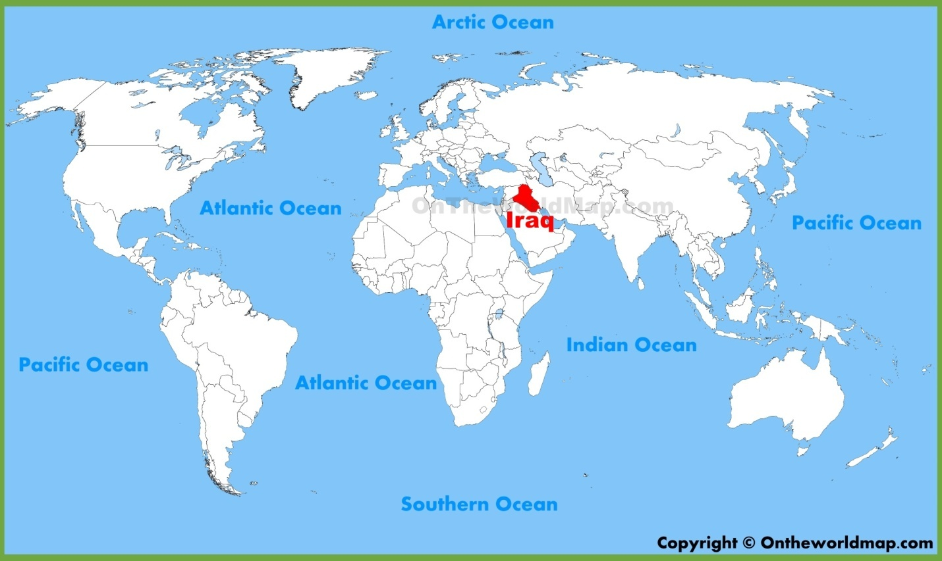
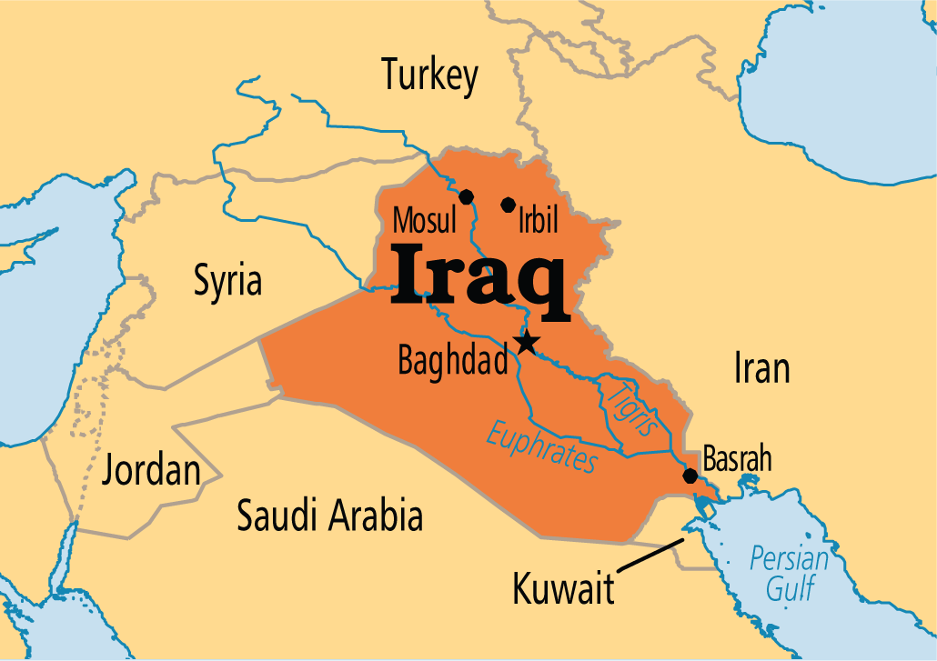
Iraq is bordered on the north by Turkey, on the east by Iran, on the southeast by the Persian Gulf and Kuwait, on the south by Saudi Arabia, on the west by Jordan, and on the northwest by Syria. Iraq is divided into three distinct zones: the desert in the west and southwest; the plains; and the highlands in the northeast.

Facts about Iraq:
Let me ask you a question here. Does anyone know the old name of Iraq?
The earlier name of Iraq was Mesopotamia, is often referred to as the cradle of civilization. Iraq occupies the ancient region of Mesopotamia, "land amidst the rivers," fertile lowland created by the Tigris and Euphrates Rivers.

Some other facts:

- The oldest known writing system developed in Iraq around 3200 B.C. Known as cuneiform, it used about 600 signs instead of an alphabet. Each sign stood for a word or a syllable.
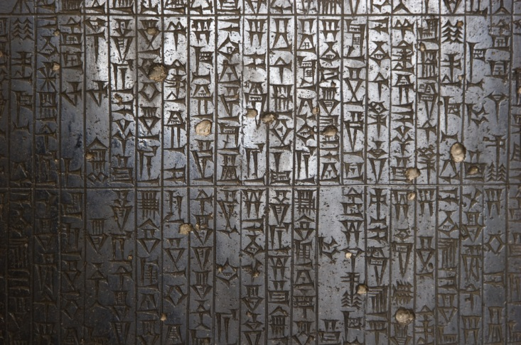

- The Epic of Gilgamesh, the world’s first written story, narrates the adventures of a legendary king who fought to preserve an ancient Iraqi city.
- Ancient Iraq was the birthplace of some of the world’s most important inventions, such as the 60-second minute and the 60-minute hour, the wheel, writing, the first accurate calendar, the first maps, and the first schools.
- The famous children’s story Ali Baba and the Forty Thieves was written in Iraq about 1,000 years ago.

After knowing about these above facts, it is also interesting to learn about its archaeological treasures which have been mentioned below.
Iraq has a lot of archaeological treasures but most of them have been moved to other countries for display, so that people can learn and know more about Iraq

. 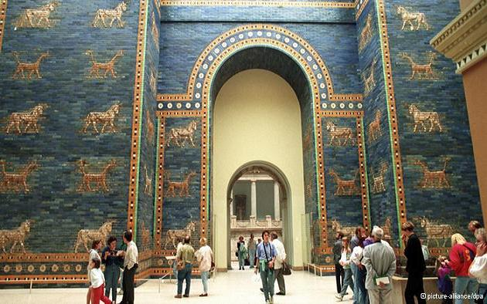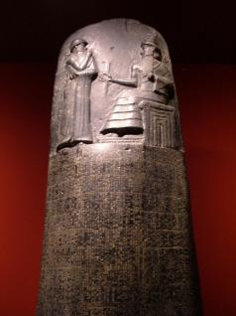
Besides above treasures that Iraq possess, it also take pride in its unity in diversity with different nationalities and religions living under same roof with harmony.
Nationalities, religions:
So, Iraq has many nationalities hence it also has many religions and my next point is about the religions.
Religion in Iraq:
96% of Iraqis follow Islam. Christianity accounts for 0.8%, and the rest practice Mandaeism, Yazidism and other religions. Judaism first came to Iraq under the rule of the Babylonian king Nebuchadnezzar II of Babylon. It was a part of the Babylonian Captivity. After the 6 Day War in Israel, rioting caused the majority of Jews to flee and now only a few Jews remain in Iraq.
Iraqi Arabs includes 72-75%, Kurds (including Feylis,Yazidis, Shabaks and Kaka'is): 20-22%, Turkmen: 2%, Assyrians: 2%, other: 1% (Armenians, Circassians, Persians,Mandaeans/Sabians, Bahá'ís and Afro-Iraqis and Doms).
Islamic civilization was known as the Dark Age but now I am going to show you a very interesting video about Islamic civilization, where you will see how dark age turned into golden age.

Now let me tell you about its culture which is as vibrant as its treasures and its people.
Iraqi Culture

The People
. As of July 2011, the population of Iraq was 30,399,572 and ranked 39th in the world.
The Iraqi population includes a number of ethnic groups, about 77% of whom are Arabs, 19% Kurds, and the rest a variety of different groups, including Turkomens, Assyrians, and Armenians. There is also a distinct sub-group of Iraqi Arabs, called the Ma'dan or Marsh Arabs, who inhabit miles of marshy area just above the point at which the Tigris and Euphrates join together. Iraqi families are usually large and family relationships are close. Most families live in one house, which is expanded when the family grows

Meeting People
The most common greeting is the handshake coupled with eye contact and a smile. The standard Arabic/Islamic greeting is "asalaamu alaikum" ("peace be with you"), to which the response is "wa alaikum salaam" ("and peace be unto you"). Good friends of the same sex may greet each other with a handshake and a kiss on each cheek, starting with the right.
Expect to be introduced to each person individually at a small social function. At a large function, you may introduce yourself.

Hospitality

Hospitality is an Arab and Muslim tradition deeply engrained in the culture. Visitors are treated as kings and must always be fed and looked after. A tradition within Islam actually stipulates someone is allowed to stay in your home for 3 days before you can question why they are staying and when they will leave, Invitations to a home must be seen as a great honor and never turned down.

Iraq also takes pride in its cuisine which is equally cherished and cooked in many homes. I am sure you will also like it and may be you would like to try or perhaps cook by yourself at home.

Cuisine
Iraqi cuisine mirrors that of Syria and Lebanon, with strong influences from the culinary traditions of Turkey and Iran. Popular dishes include kebab (skewered meat, typically beef), falafel (fried chickpea balls), kofta (Iraqi meatballs) and masgouf as well as small portions like dolma (grape leaves stuffed with vegetables, rice and sometimes meat).

The Arab’s hospitality is different and so is its language, which is beautifully craved and written however, it is also one of the most difficult languages to learn.

Why is Arabic language popular and beautiful, but it is also difficult to learn?
Arabic is the national language and is the mother tongue of an estimated 79% of the population. Kurdish—the official language in Kurdish regions—or a dialect of it, is spoken by the Kurds and Yazidis. Aramaic, the ancient Syriac dialect, is retained by the Assyrians. The Turkomans speak a Turkic dialect. Armenian is also spoken

Arabic is the Classical Arabic language of the 6th century and its modern descendants, excluding Maltese. Arabic is spoken in a wide arc stretching across Western Asia, North Africa, and the Horn of Africa. Arabic belongs to the Semitic branch of the Afro-asiatic family. Arabic usually designates one of three main variants: Classical Arabic, Modern Standard Arabic and colloquial or dialectal Arabic. Classical Arabic is the language found in the Quran, used from the period of Pre-Islamic Arabia.
It is difficult. I speak Arabic because it is my native language. There are quite a few different dialects. And for all those dialects there is a formal Arabic spoken in the media, by politicians, clergymen etc. It is the same dialect in the Koran. Which is a very formal type of Arabic. Since I grew up speaking the "street" language in the dialect of my parents homeland, the formal Arabic is difficult even for me to master its grammar or vocabulary.
Not only that, there are lots of letters and sounds that do not exist in the English language. Most Arabic speakers who have been speaking it since birth develop a different set of muscles or facial features to accommodate some of the sounds in our language. You must learn to speak from the back of your throat in order to properly make some of the sounds required for speaking Arabic.
However, like any language it is learn-able. Be patient. Do not give up. And you have to be prepared mentally and understand where you need to start from. May I suggest you study abroad So I know you can do it. Do not be discouraged. Learn as much as you can. And yes it is a hard language to learn, but I can assure you like anything else in life, it will be a great accomplishment for you.
Introduction to the Alphabet
Arabic is read from right to left
Almost all the letters in an Arabic word are joined together like hand writing
Some letters can’t join because of their shape.
There are 28 letters in the Arabic alphabet
There is no such thing as capital letters versus small letters
There is no such thing as printing versus hand writing, Arabic is all hand writing.
Just about all Arabic vocabulary is made up of root/stem consonants that you can easily memorize.
The letters are shown below
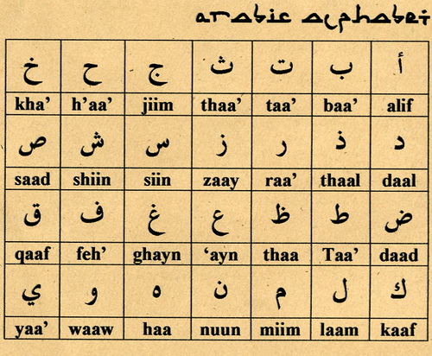
Each letter has 4 forms (which look very similar to each other)
o when you write the letter by itself
o when it comes in the beginning of a word
o when it comes in the middle of a word
o when it comes at the end of a word

Now, let’s us do something very interesting that you will love it. Let’s try to speak a little Arabic with me. You will need to repeat after me. This is going to be very easy
Music and poetry:

Performance Arts. Music festivals have been important, such as the Babylon International Music and Arts Festival (last held in 1987 and 1995). International orchestras and performance troupes were invited to perform in the restored sites of Babylon, and people from all over the world attended. At present due to the harsh and severe living conditions, there are no resources to allocate to performance arts.
Chalghi performance, Baghdad
Iraqi music has its historic roots in ancient traditions but has continued to evolve through various eras. From creation of the oldest guitar in the world and the invention of the lute, to adding a fifth string to the rhythms and the various Iraqi maqams, Iraqi music proves to be an important part of the country's culture.
Renowned Iraqi composers include Abbas Jamil, NazimNaeem, Mohammed Noshi, Reza Ali, Kamal Al Sayid, Kawkab Hamza, Talib Ghali, Hameed Al Basri, Tariq Al Shibli, Mufeed Al Nasih, Jaffer Al Khafaf, Talib Al Qaraghouli and many others.
The traditional music of Iraq is the maqam, which is based on Arabic poetry and is very heart wrenching and slow. Maqam musical scales are said to have been influenced by the courts of ancient Arabic kings and by the Persians (ancient Iranians).

Mohammad Mahdi Al-Jawahiri
Iraq is home to prized art and literature which have always thrived in Iraq. The nation of Iraq produced one of the greatest Arab poets of all time: Abu Al Tayeb Al Mutanbi of the Abbasid Period. Modern-era poetic contributors include Mohammad Mahdi Al Jawahiri, Nazik Al Malaika, BadrShakir Al Sayyab, Jameel Sidqi Al Zahawi, Ma’sroof Al Rusafi and Abdul Wahab Al Bayati.

